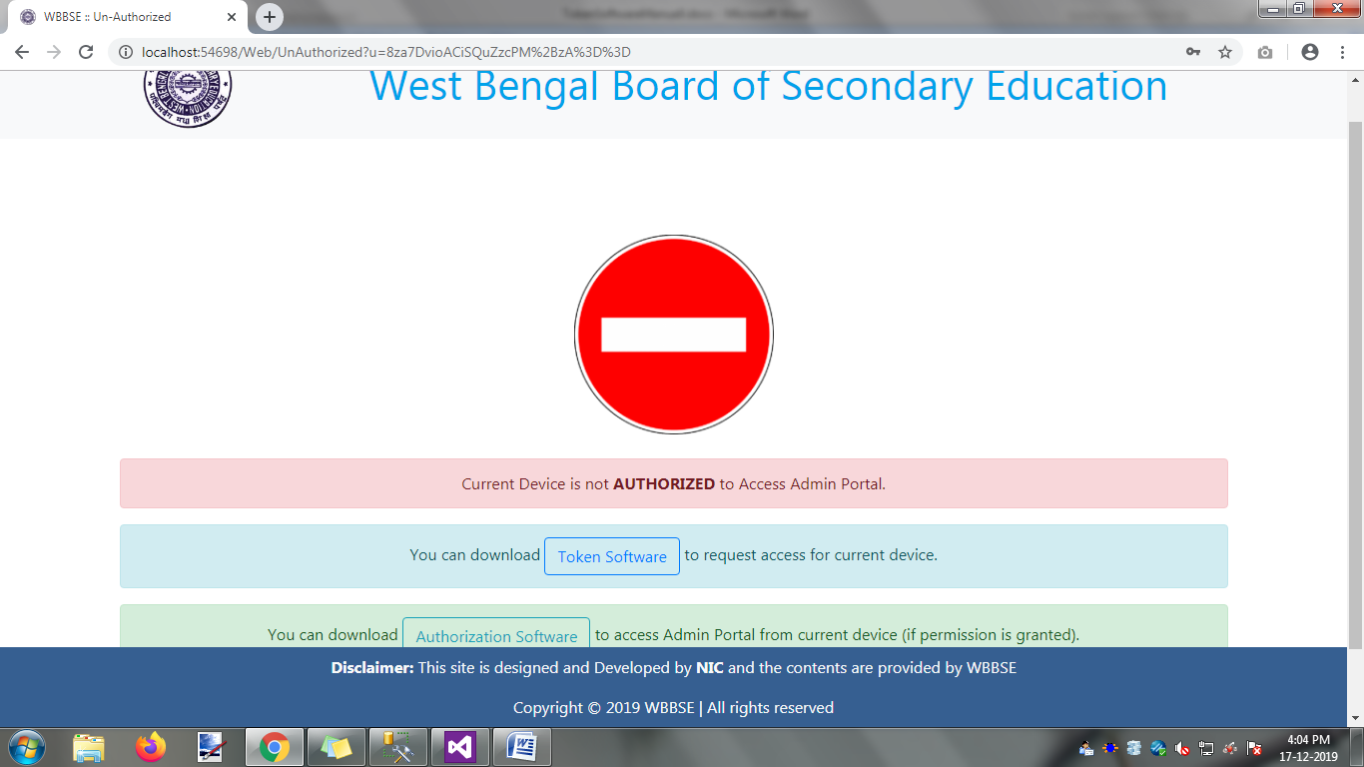

Click on the Authorization Software button,the following will happen

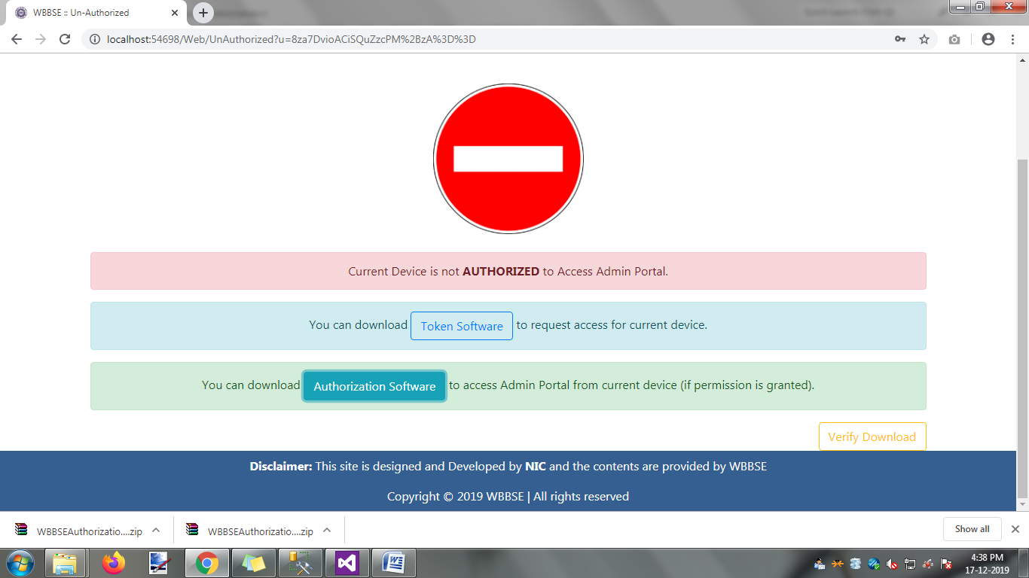

Download the file ‘WBBSEAuthorization.Zip’.After completion of downloading file, the following step is as follows .

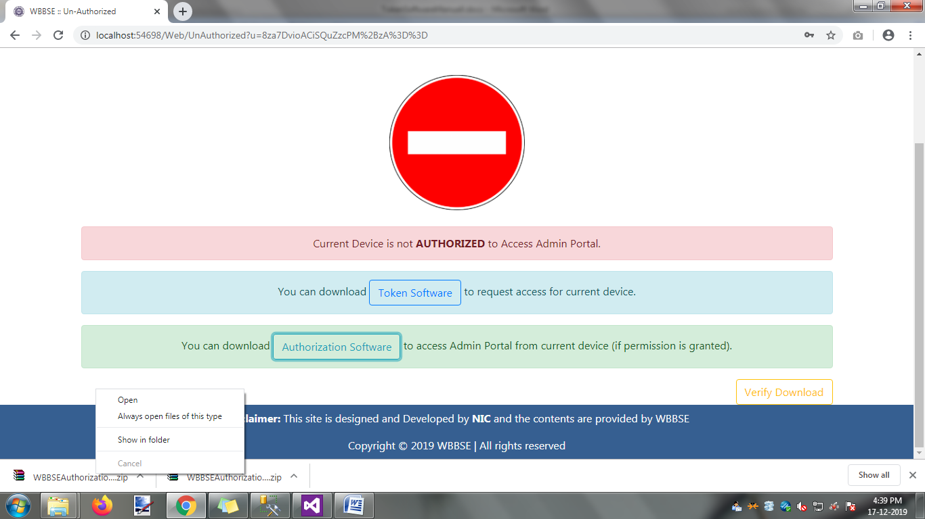

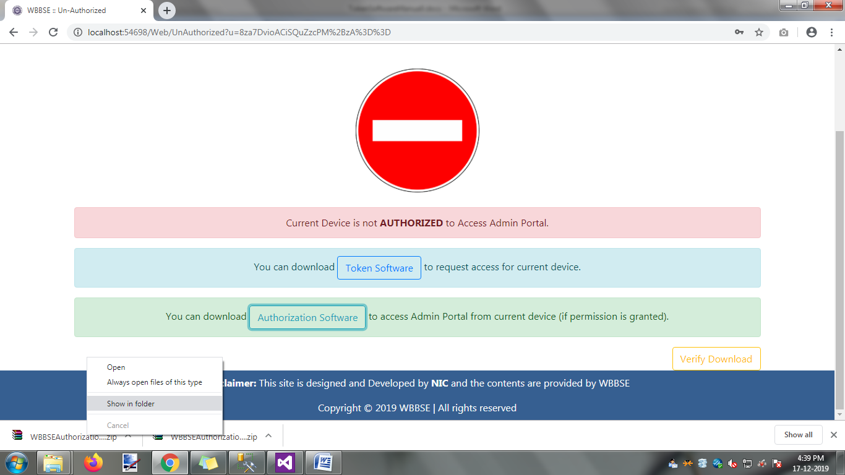

Click on the option ‘Show in folder’,the file download location is appear .

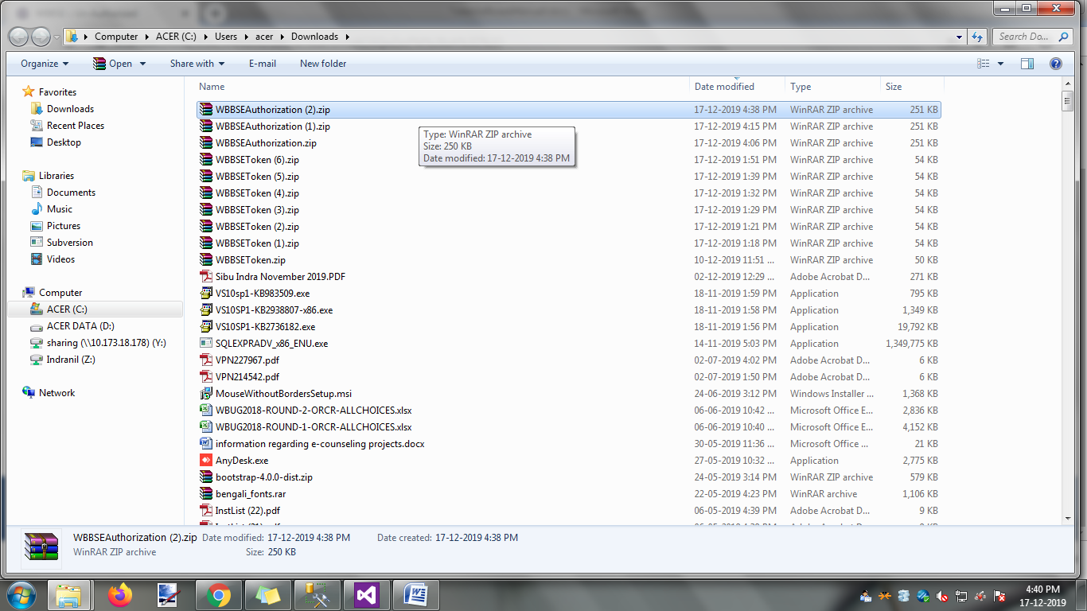

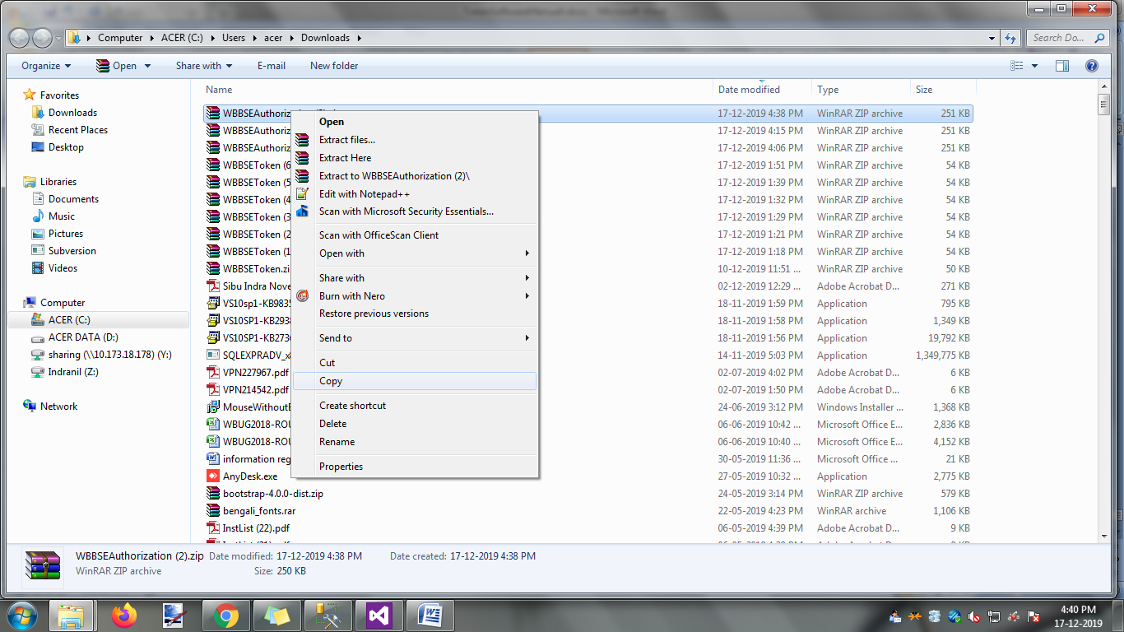

Create One new folder name as ‘WBBSEAuthorizationFile’ in your local drive.Copying the download file and it’s paste your destination location.

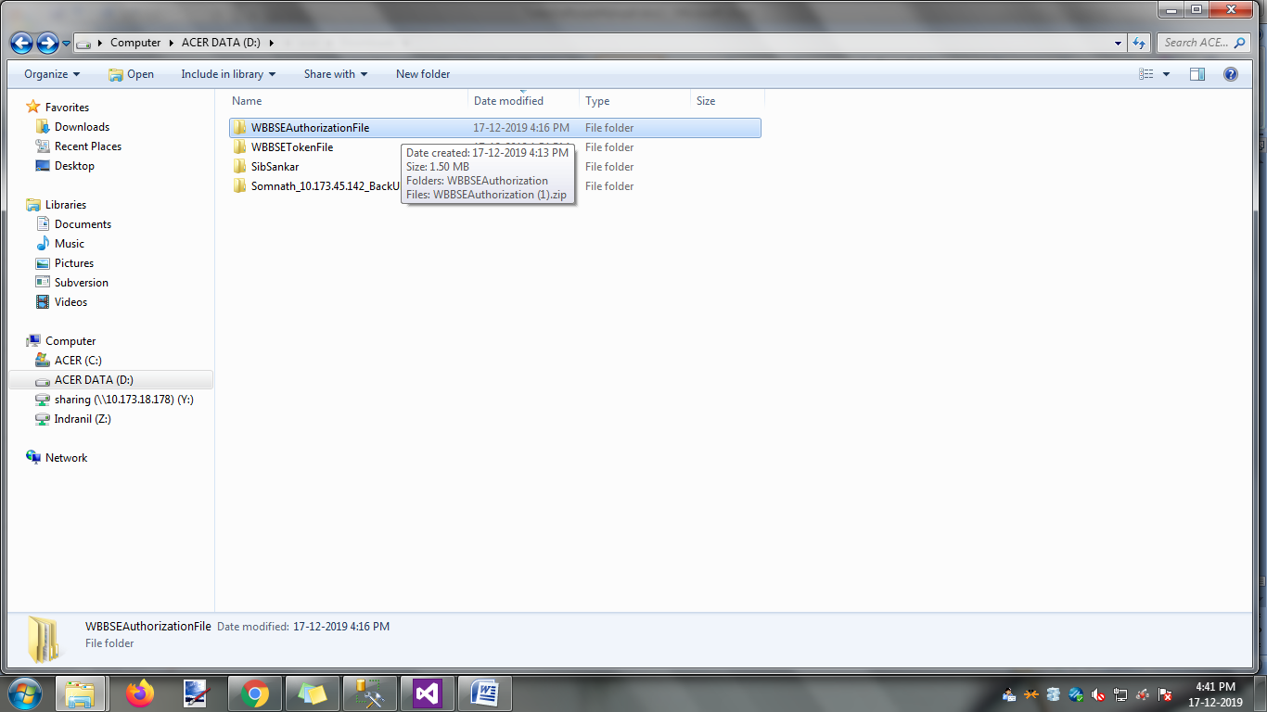

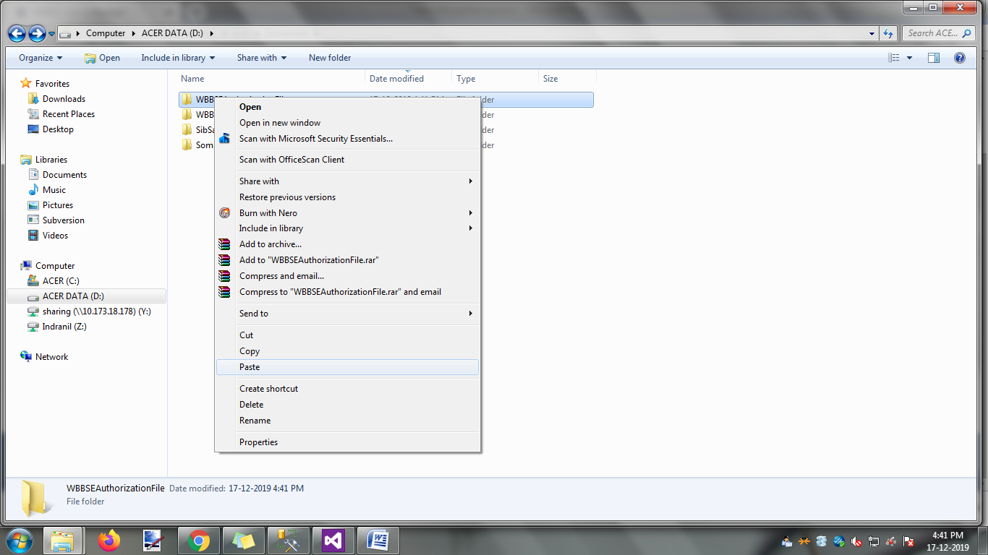

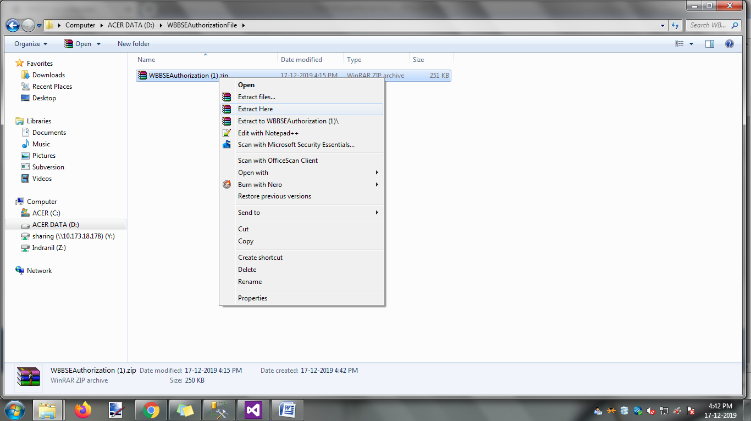

Click on the option ‘Extract Here’

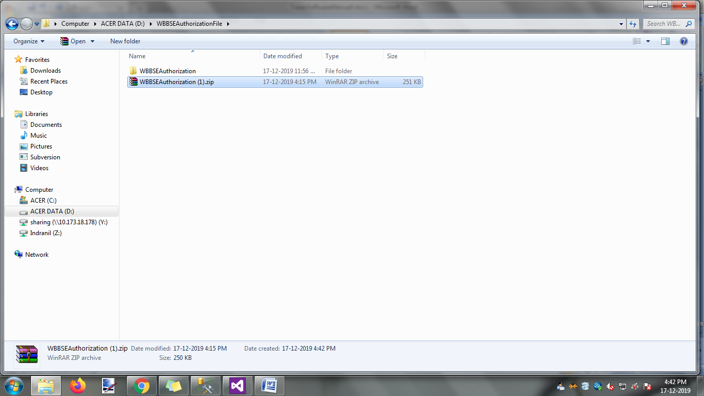

One new ‘WBBSEAuthorization’ folder was created.

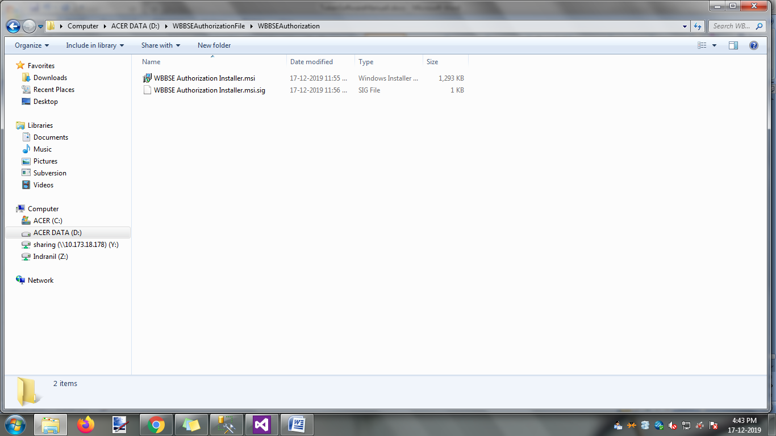

Click on ‘WBBSEAuthorization’ folder ,open one new window and the following file are display. Click on the file ‘WBBSE Authorization Installer.msi’

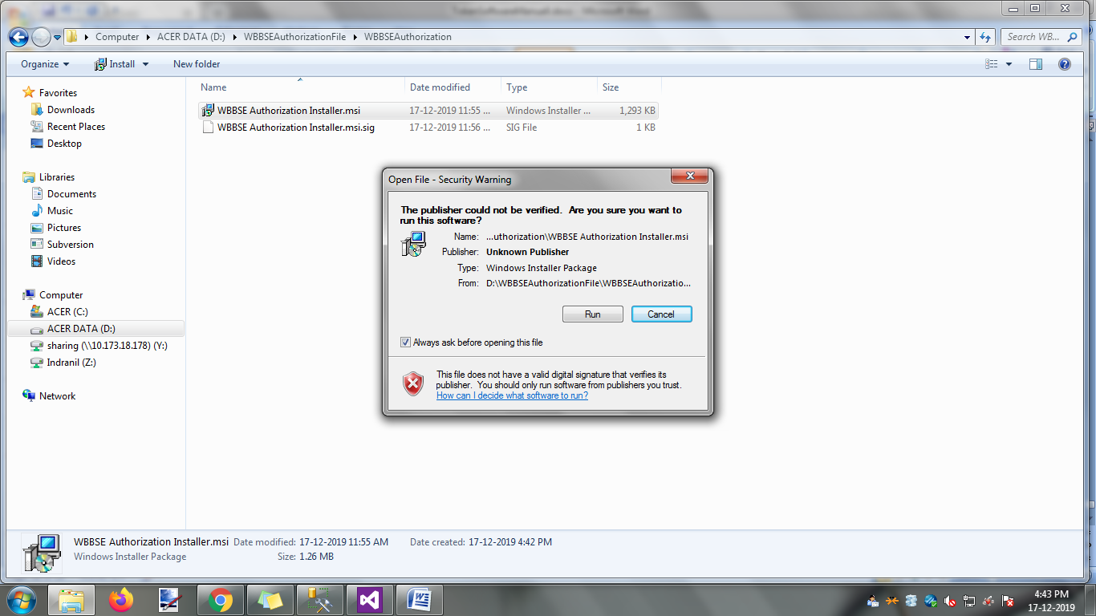

Click on ‘Run’ button.The following action is appear.

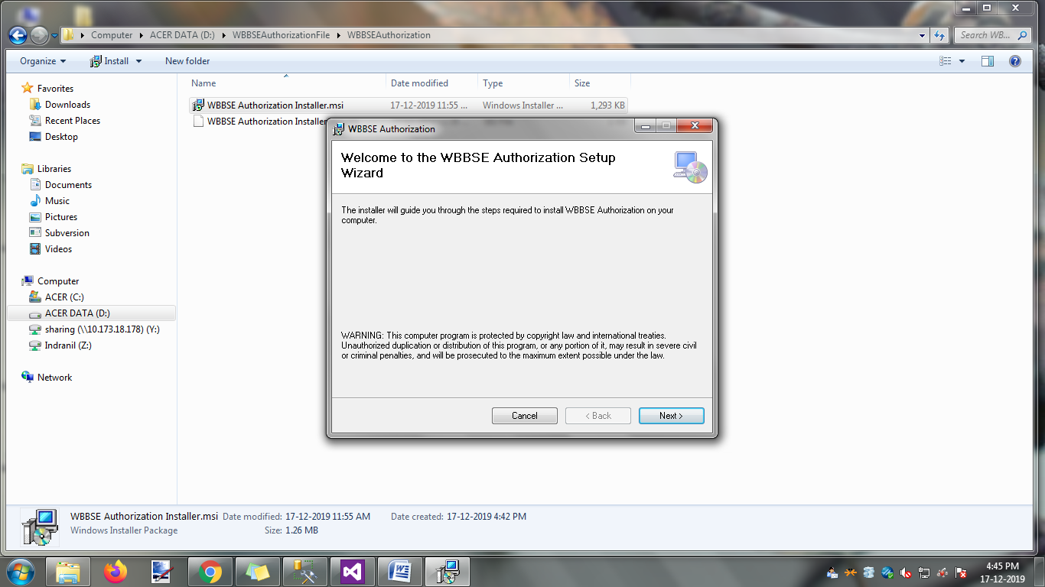

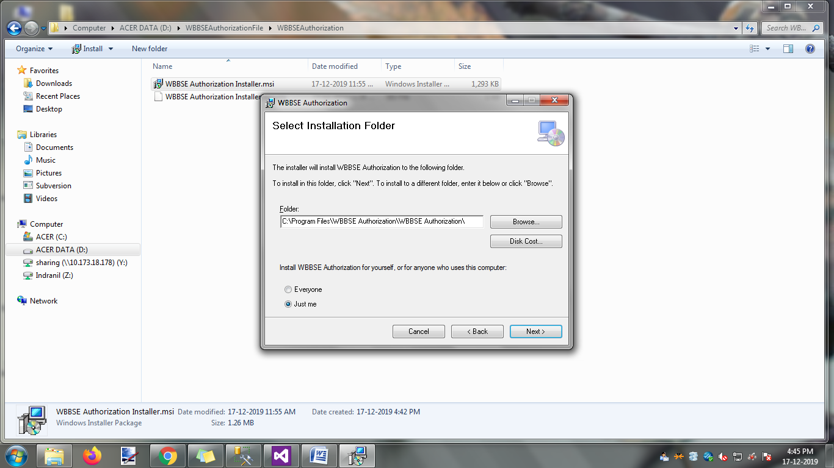

Click on ‘Next’ button .

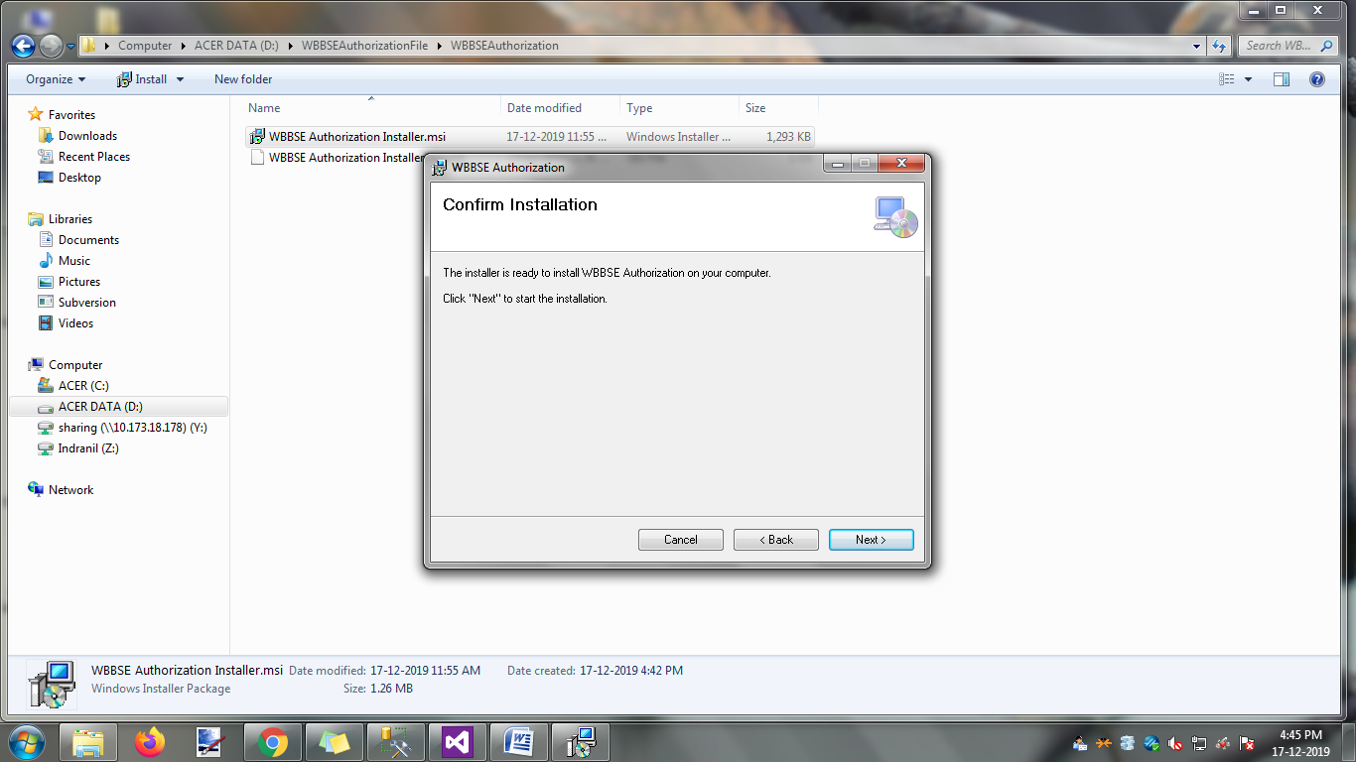

Click on ‘Next’ button .

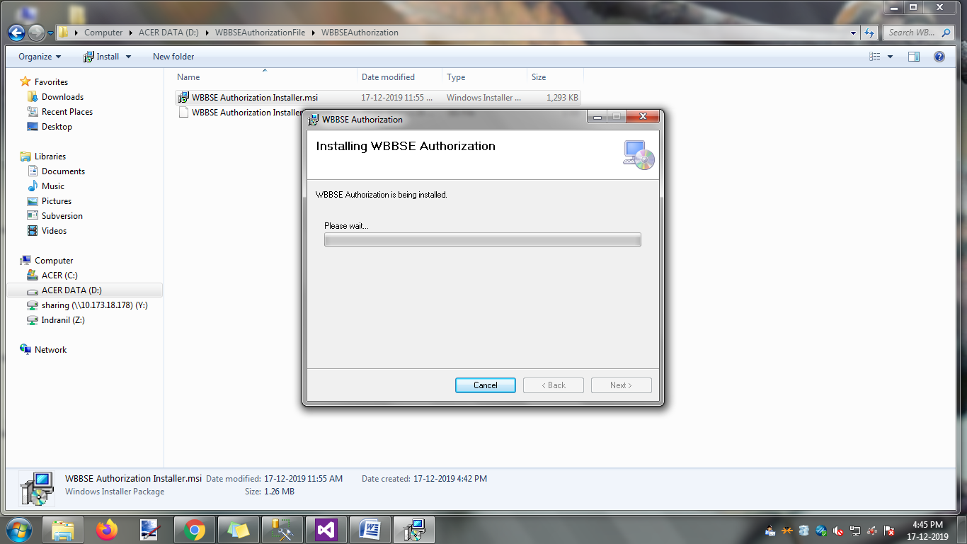

If you click on ‘cancel’ button then installation process is terminated.

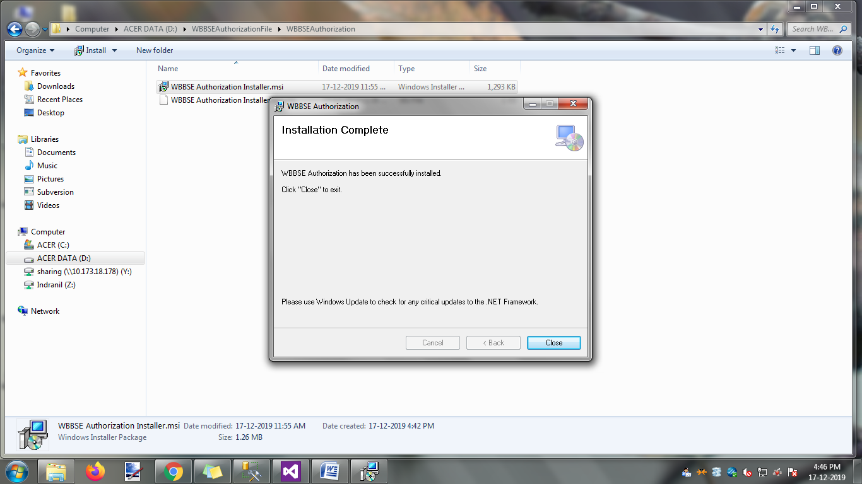

Click on ‘Close’ button .

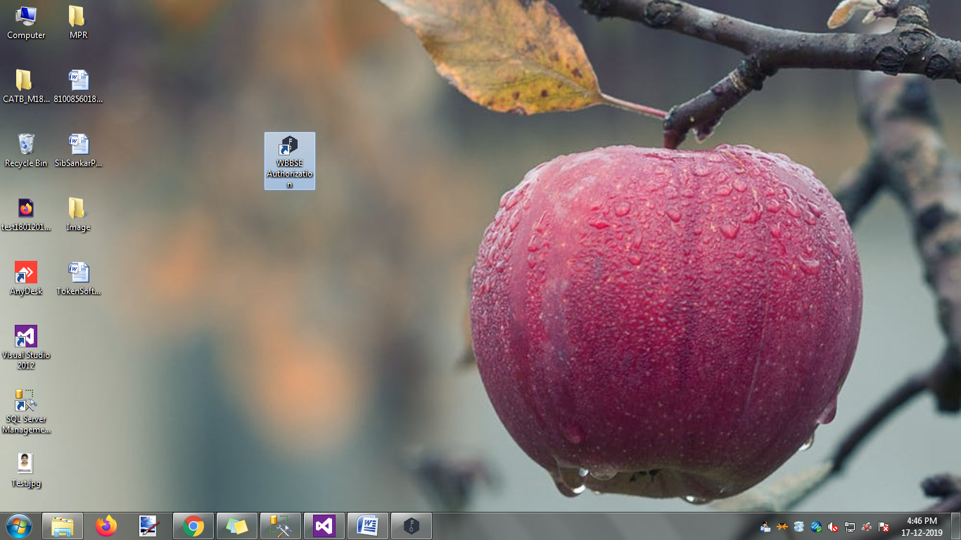

After complete the installation ,one ‘WBBSEAuthorization’ icon/ logo display in the desktop background.Click on this icon then the following action is take place.

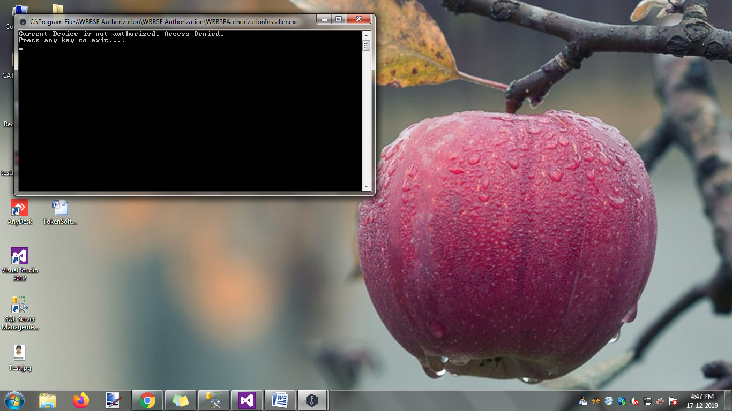

If Authorized permission is ‘No’, then no webpage is open in your default browser.

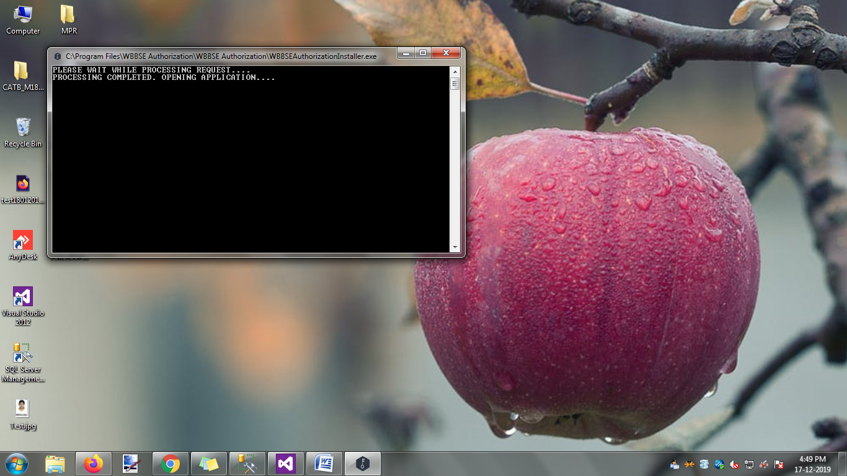

If Authorized permission is ‘Yes’, then one webpage is open in your default browser.

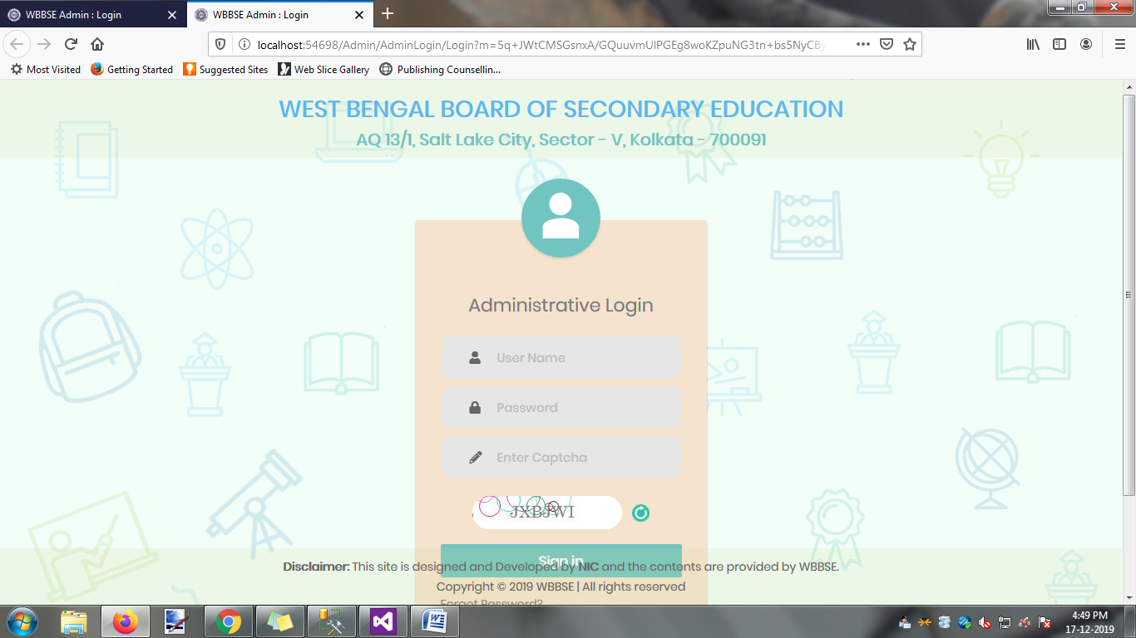

Plese follow the login instruction.

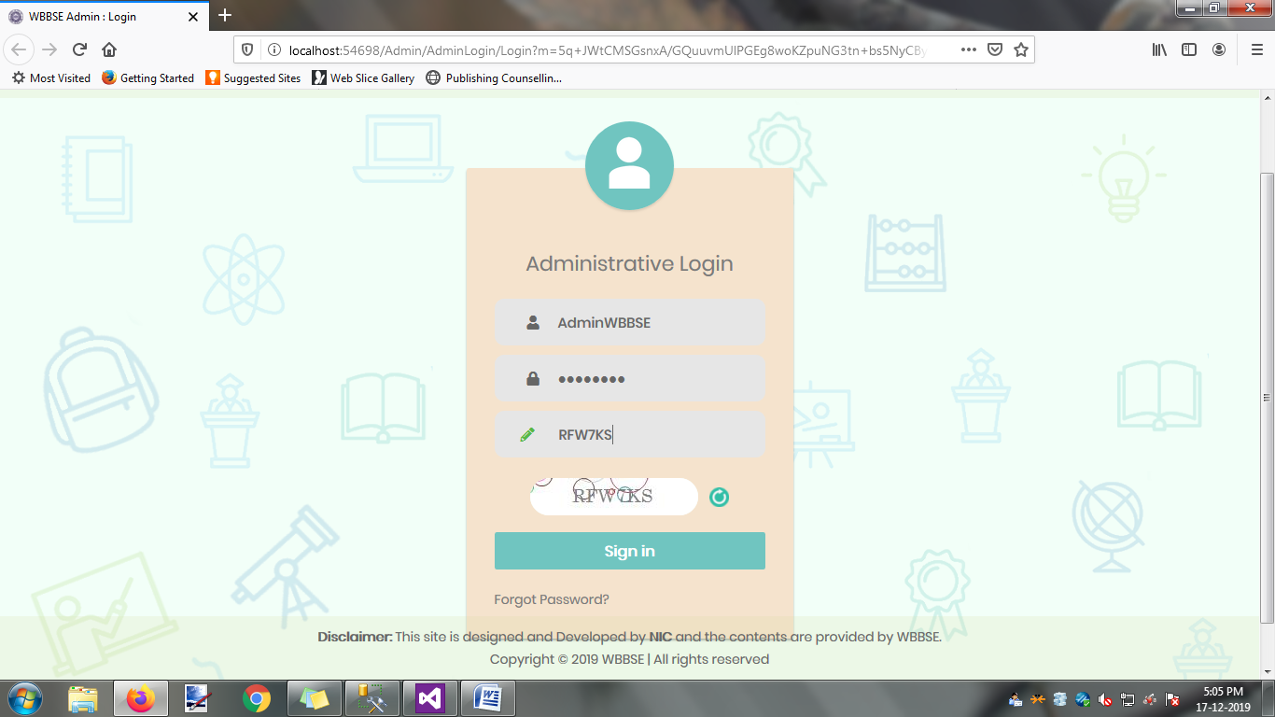

After completion of login, the following Deshboard is display in your web browser.

